LESSON TITLE: "Creating the Illusion of Space"
TIME FRAME: 2 - 3 weeks
LEVEL: Advanced Middle School to Beginner High
School
OBJECTIVES
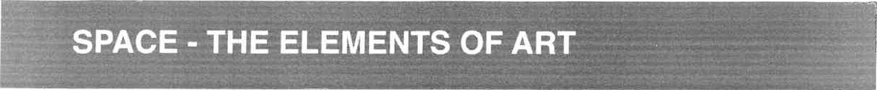
MATERIALS FOR THIS LESSON:
- White drawing paper 18" by 24"
Soft graphite pencils
- Rulers or yardsticks

The student will learn six ways to create the illusion of space on a flat surface. The student will learn how to create the illusion of space using one point linear perspective and two point linear perspective.
DESCRIPTION
Students will use their knowledge of linear perspective to create a 3-D maze using graphite and white drawing paper.
VOCABULARY
Space - In terms of art, space is the area around, above, below, and within objects
Overlapping - Overlapping occurs when objects that are closer to the viewer prevent the view of objects that are behind them.
Size - Objects that are smaller will appear further away from the viewer.
Placement on the paper - Objects placed higher within the picture plane will appear further away.
Detail - Objects that are further away should have less detail than objects that are closer to the viewer,
Color - Objects that are further away are cooler in color temperature, while objects that are closer are warmer.
Value - Objects that are further away are lighter in value, while objects that are closer are typically darker in value.
Linear Perspective - Linear perspective is a drawing method that uses lines to create the illusion of space on a flat surface.
One Point Perspective - A form of linear perspective in which one vanishing point is placed on the horizon line.
Two Point Perspective - A form of linear perspective in which two vanishing points are placed on the horizon line.
KEY POINTS / ESSENTIAL QUESTIONS
- What is space?
- How is the illusion of space created in artworks by artists?
- What are the differences between one point and two point perspective?
- Why is the illusion of space important in artworks?
GUIDED PRACTICE
The teacher will present the presentation entitled "Space". When each method for creating the illusion of space is presented in the presentation, the students should draw examples in their sketchbooks. One point and two point perspective should be more in depth. Teachers may choose to lead in the development of a drawing of a city or a small grouping of buildings,
Teachers should demonstrate the process of drawing a 3-D maze using two point perspective. Students will use graphite and white drawing paper to complete a drawing of a maze using two point perspective. Drawings should include a range of value and a clearly defined light source. (See project example below,)
